1. **Create VPC with 2 private and 2 public subnets.**

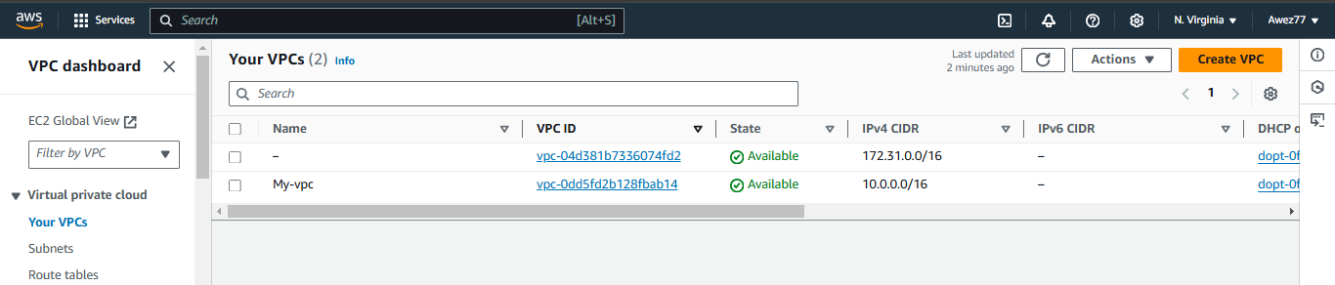

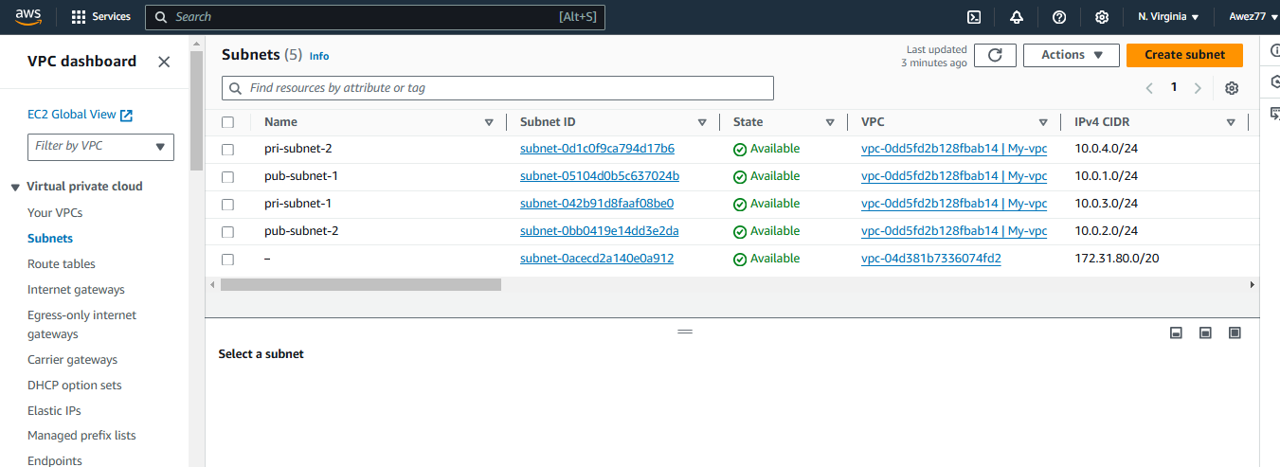

1. **Enable DNS Hostname in VPC** 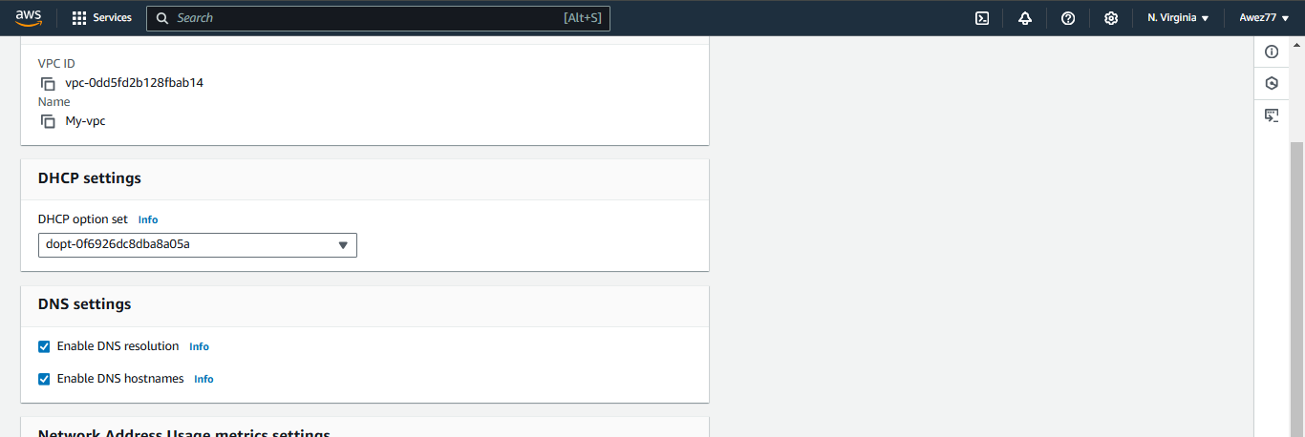

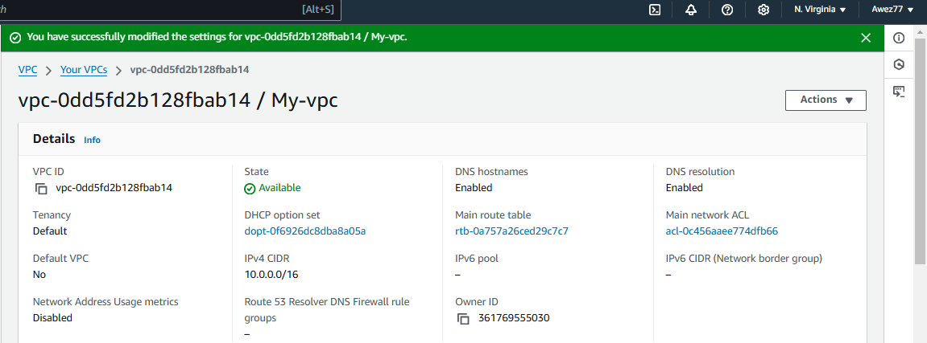

1. **Enable Auto Assign Public ip in 2 public subnet**

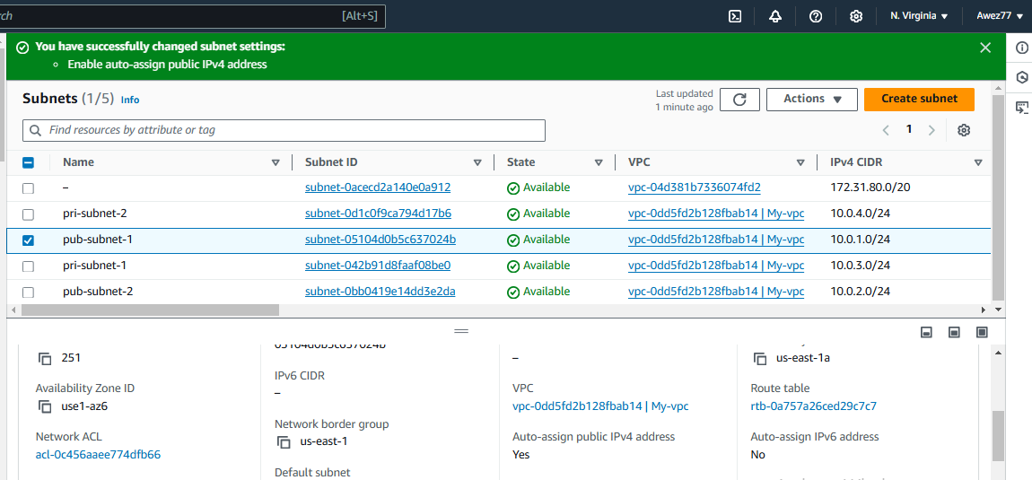

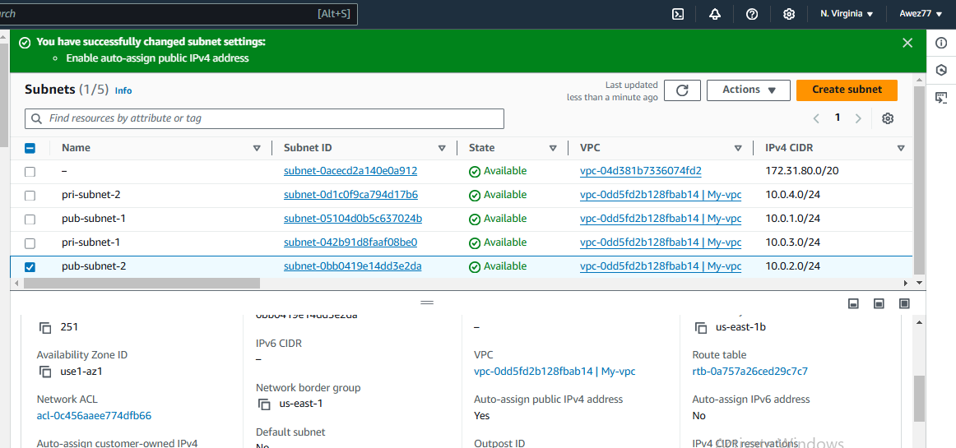

1. **Add 2 private subnets in private route table**

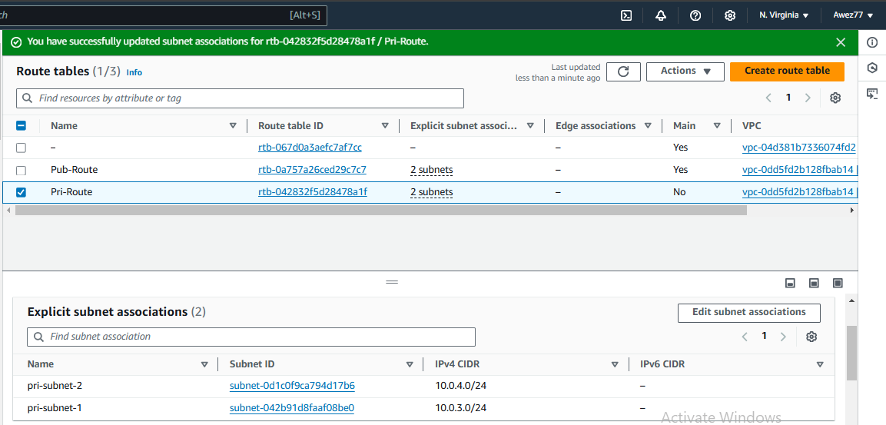

1. **Add 2 public subnets in public route table**

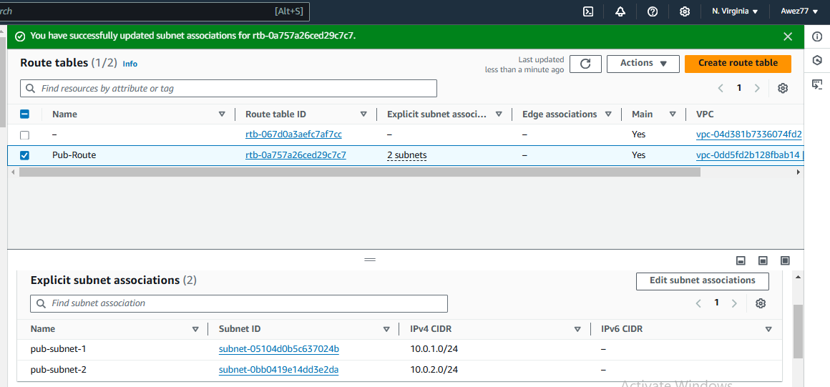

1. **Public route table will have the routes to internet and local**

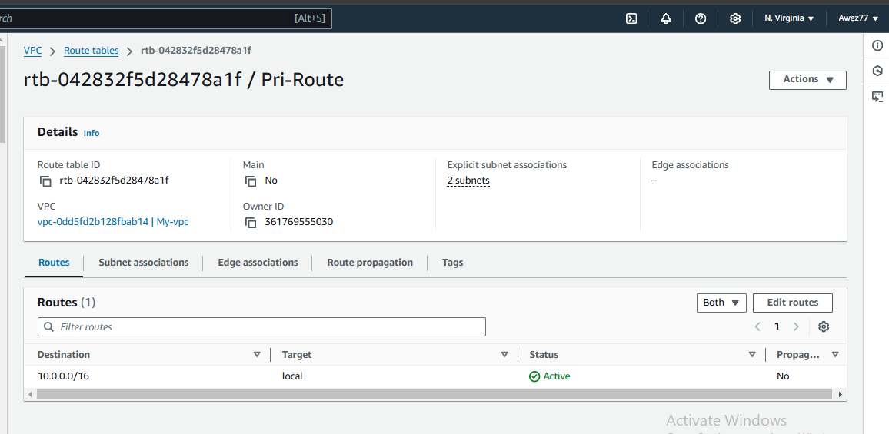

1. **Create Ec2 in public subnet with t2micro and install php**

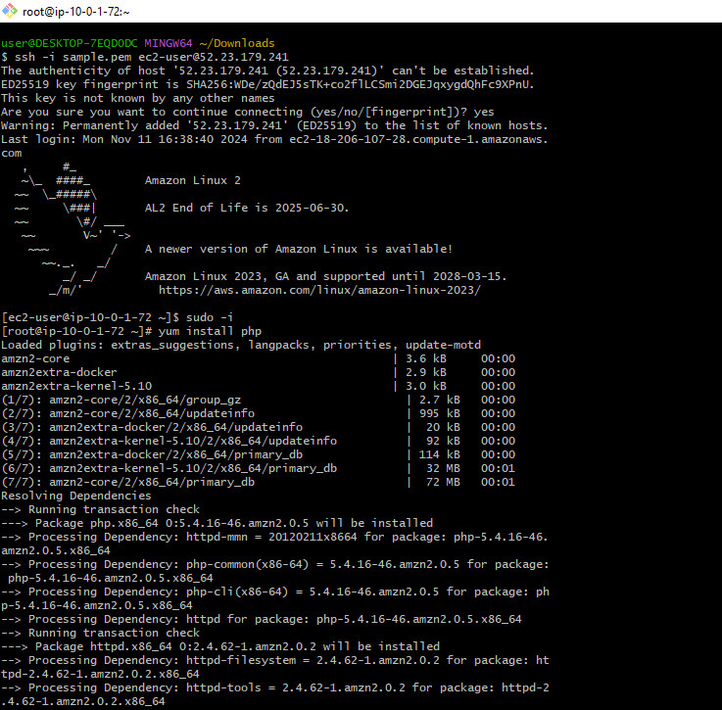

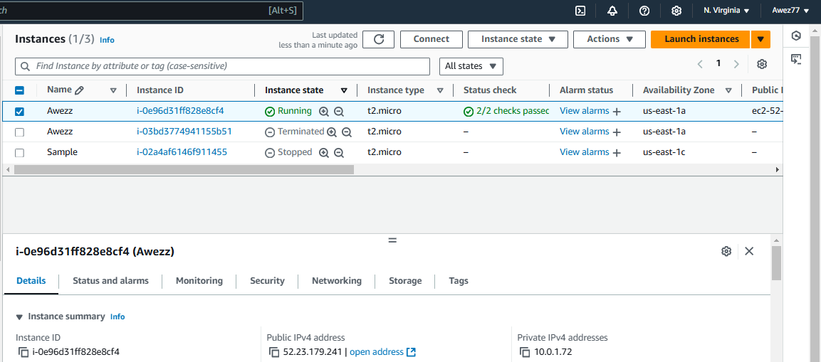

1. **COnfigure Nat gateway in public subnet and connect to private Instance**

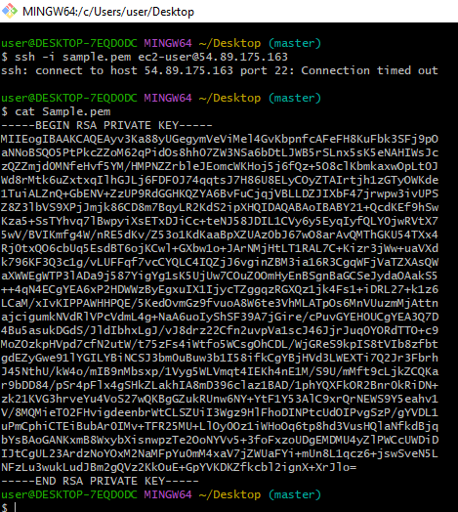

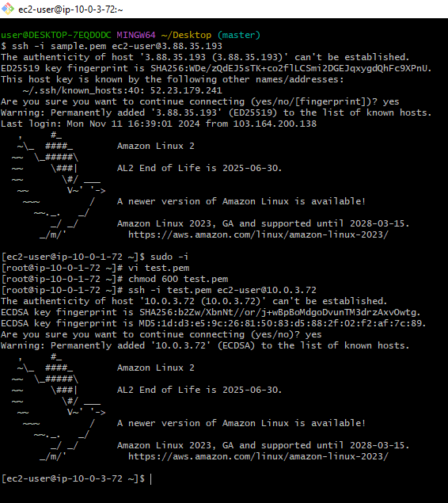

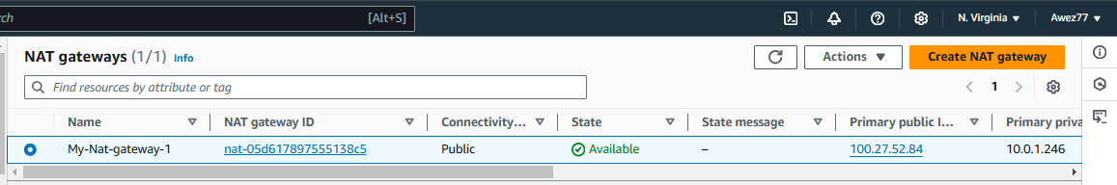

1. **Install Apache Tomcat in private ec2 and deploy a sample app.**

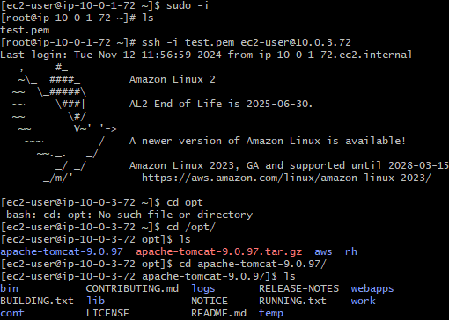

**10) COnfigure VPC flow logs and store the logs in s3 and cloudwatch.**



